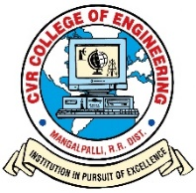**CVR COLLEGE OF ENGINEERING**

(An UGC Autonomous Institution with NAAC ‘A’ Grade, Affiliated to JNTUH)

Vastunagar, Mangalpalli (V), Ibrahimpatan (M), R.R. District, Telangana

Ph. No:91-8414 – 661601, 661675

**DEPARTMENT OF ELECTRONICS AND COMMUNICATION ENGINEERING**

**INDUSTRY ORIENTED MINI PROJECT CONSENT FORM**

ACADEMIC YEAR 2020-2021

|  |  |  |  |
| --- | --- | --- | --- |
| CLASS: III Year ECE | | | SECTION: D |
| **S.No** | **Name of the student** | **Register number of the student** | **Batch no** |
|  |  |  |  |
| 1. | BEHERA SUBHASHISH | 18B81A04P0 |  |
| 2. | KATTEKOLA UPENDER | 18B81A04P3 | D15 |
| 3. | SUKKA PRIYA BHANDHAVI | 18B81A04M1 |  |



**Domain of project work: WIRELESS COMMUNICATION**

**Title of project work:** AUTOMATED VEHICLE CONTROL SYSTEM USING HAND GESTURES

Name of the supervisor: Signature of the supervisor: